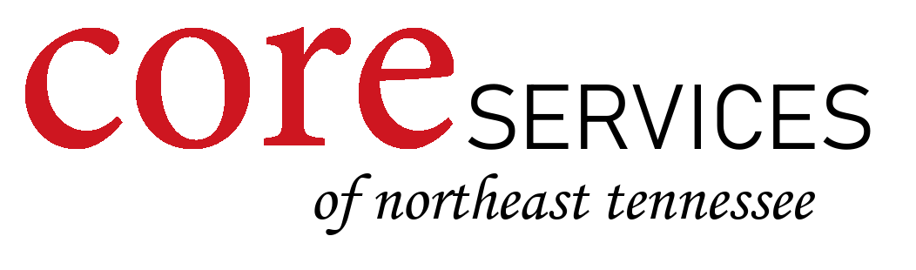

People have Privacy Policy

Personal information being shared only with people’s permission or that of the legal representative is one way that we respect the privacy of people. Information sharing is important in our goal of delivering better, more efficient person centered support services. Sharing information between shifts in a home, with management staff, and with the agency RN for healthcare oversight are important in keeping people safe and happy. However, information sharing is only on a need to know basis and should never be shared outside of that realm without the persons or their conservator’s permission. It is important that people and their conservators remain confident that their personal information is kept safe and secure and that staff maintain the privacy of the individual. Not only is it important but it is also Federal law with legal implications for the individual employee and agency for lack of compliance.
Even within the agency, when staff have heard about physical management needs, behavioral concerns, medical or other issues of an individual with whom they have never worked, privacy rights have been violated. For example if everyone in a training class, has heard about the behaviors of Suzy, and no one in that class has ever worked with Suzy, Suzy’s rights have been violated.
In addition people have the right to a place and opportunity to be by themselves during the day.
People have a right to privacy and respect when needed supports for dressing and personal hygiene are provided or when someone is entering their room(s).
Expectations for privacy also apply to all visitors in an individual’s home.

As an employee of Core Services of Northeast Tennessee I understand and will respect privacy expectations as stated in this policy.

Print Name:___________________________________

Signature: ___________________________________________ Date:__________________

