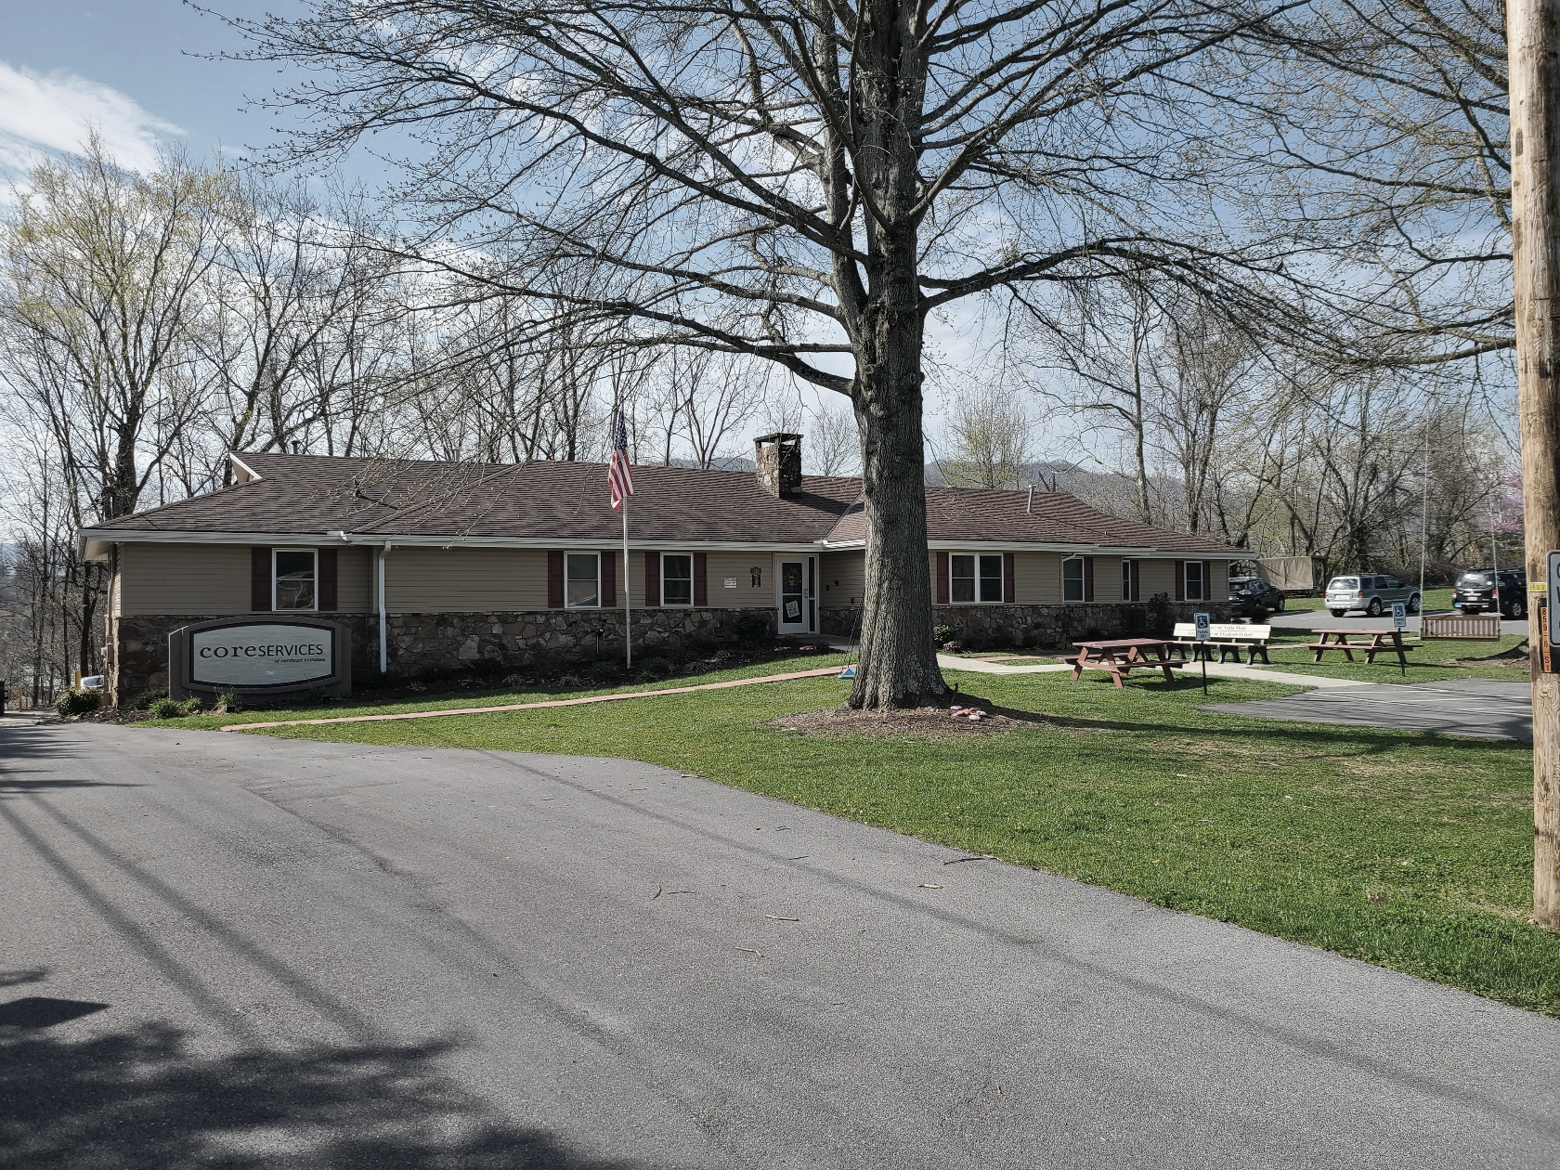

Pre-Employment Transition Services

MANUAL

215 University Parkway
Johnson City, TN 37604
423.928.2752
www.coreservicestn.com

Pre-ets is available through a grant contract between the state of tennessee, department of human services and core services of northeast tennessee

Pre-Employment Transition Services Manual
Table of Contents

- About Core Services of Northeast Tennessee……………………. | 3
- Intro to Pre-ETS…………………………………………………………………. | 4-7
- Pre-ETS Job Descriptions…………………………………………………… | 8-11
- Instructor Expectations……………………………………………………. | 12
- Hiring Process………………………………………………………………….. | 13
- Training……………………………………………………………………………. | 14
- Services Offered………………………………………………………………… | 15-18
- Curriculum………………………………………………………………………… | 19
- Forms……………………………………………………………………………….. | 20-22
- Electronic Case Management - Practical Health Systems  - Set Up and Clocking In……………………………………………..  - Navigating PHS Pre-ETS Menu…………………………………  - Completing a Student Report…………………………………. | 23-28  23-26  27  28
- Resources………………………………………………………………………….. | 29-35

Pre-ETS is funded by

WORKFORCE INNOVATION & OPPORTUNITY ACT

Public Law 113–128 (29 USC 3101)

TITLE IV—AMENDMENTS TO THE REHABILITATION ACT OF 1973

ABOUT CORE SERVICES
Core Services of Northeast Tennessee, (d.b.a.), a division of Washington County Community Residential Services, Inc.; is a 501 (C) (3) private, non-profit organization serving the needs of people with intellectual and/or developmental disabilities in Northeast Tennessee. Core Services is contracted with the State of Tennessee, Department of Intellectual and Developmental Disabilities (DIDD) to provide residential and day services for adults with IDD including supported living, employment, respite, personal assistance, funds management, nursing, and more. The agency was originally established by a group of concerned parents in the 1960’s and has a long-standing history of support services in the Tri-Cities.
VISION -People with intellectual disabilities participate in, contribute to, and are valued members of their chosen community
MISSION – We are committed to empowering people with intellectual disabilities to live a shared vision of a valued life in connection with family, friends, and community life.
The agency completed the Tennessee Department of Intellectual and Developmental Disabilities requirements for designation as a “Person-Centered Organization”, an “Enabling Technology Transformation Agency” and is a provider mentor through the Tennessee Employment First Leadership Initiative (TEFLI). Core Services has an Employment First philosophy and believes that everyone should have the opportunity to work. This philosophy aligns with the goal of Pre-Employment Transition Services; thereby, prompting the agency to become a grantee beginning the 2019/2020 academic year.
In 2021 Core Services achieved the highest level of accreditation, Person-Centered Excellence Accreditation with Distinction, recognized by the Council on Quality and Leadership |CQL. CQL offers accreditation, training, certification, research, and consultation services. Core Services is proud to be a part of this exclusive group of providers that align with the most rigorous standards in human services. Core Services is the recipient of a 2017 CQL Award of Excellence, acknowledging successes in reducing rights restrictions.
What is Enabling Technology? Enabling Technology is the use of various forms of devices and technology to support a person with disabilities to live as independently as possible. These types of technologies include sensors, mobile applications, remote support systems, and other smart devices. Enabling Technology can support a person in navigating their jobs and communities, gain more control of their environment, and provide remote support and reminders to assist a person in independent living. Core Services is a leader in the state in utilizing technology supports to increase independence.
https://www.youtube.com/watch?v=M86Z-iQV5EQ&t=91s | https://www.youtube.com/watch?v=zmYzdl2C6Cw&t=43s

Introduction to Pre-Employment Transition Services, Pre-ETS

The Tennessee Department of Human Services, Division of Rehabilitation Services describes the Pre-ETS Program as follows:
The Tennessee Department of Human Services Division of Rehabilitation Services has a strong history of working collaboratively with local education agencies (LEA) to provide transition services to students in secondary school. In 2014, the Workforce Innovation and Opportunity Act (WIOA) reauthorized the Rehabilitation Act of 1973 and placed a strong emphasis on expanding the LEA and VR collaboration by requiring VR programs to set aside 15 percent of their federal funds for the provision of Pre-Employment Transition Services (Pre-ETS) to students with disabilities, including potentially eligible students.
Tennessee VR is currently providing Pre-ETS through several different entities:
VR Staff: Pre-Employment Transition Specialists and VR Counselors
Transition School to Work (Third Party Contract Agreements)
Community Rehabilitation Providers (CRPs)
Who is eligible for Pre-ETS?
A student with a disability is an individual with a disability in a secondary, postsecondary, or other recognized education program who is not younger than the earliest age for the provision of transition services under the Individuals with Disabilities Education Act unless the state elects a lower minimum age for receipt of pre-employment services and is not younger than that minimum age (i.e., age 14); and is not older than 21; unless the individual state law provides for a higher maximum age for receipt of services under the Individuals with Disabilities Education Act and is not older than that maximum age (i.e., age 22); and is eligible for, and receiving, special education or related services under Part B of the Individuals with Disabilities Education Act or is an individual with a disability, for purposes of section 504.
Core Services of Northeast Tennessee is a grantee with the Tennessee Department of Human Services to provide Pre-Employment Transition Services to qualifying high school and middle school students with a disability.
What is Pre-ETS?
- Instruction provided at your school in collaboration with local educational agencies and a grant through the Tennessee Department of Human Services, Division of Rehabilitation Services (TN DRS).
- Pre-ETS are designed to be an early start at job exploration and will assist students with identifying career interests to be further explored through additional TN DRS services.

Pre-ETS Categories
- Job exploration counseling
- Workplace readiness training to develop social skills and independent living
- Instruction in self-advocacy
- Work-based learning experiences, which may include in-school or after school opportunities, experiences outside of the traditional school setting, and/or internships
- Counseling on opportunities for enrollment in comprehensive transition or postsecondary educational programs
Core Services APPROACH TO PRE-ets
- Instructors from local community
- Interactive, hands on instruction – engaging students in meaningful learning
- Instruction tailored to the individual needs of each student
- Bridging communication gaps through technology
- Practical applications
- Curriculum from the ATTAINMENT Company is utilized as a foundation to an individualized curriculum based on the unique needs and culture of each community/school system
Outcome for Youth
- Acquire and apply knowledge
- Develop social skills and independent living
- Learn financial literacy
- Realize orientation and mobility skills
- Gain job seeking skills
- Understand employer expectations
- Participate in workplace activities to gain and practice skills

Pre-ETS Job Descriptions
JOB TITLE: Pre-ETS Instructor
REPORTS TO: Pre-ETS Coordinator
GENERAL SUMMARY: Pre-ETS instructor is a part time position contingent upon grant funding. Instructors are responsible for teaching curriculum designed to assist high school students with disabilities to achieve a successful transition from school to employment or postsecondary education opportunities. The goal of the instruction is employment for youth upon their exit from the school system.
ESSENTIAL DUTIES AND RESPONSIBILITIES include the following and other duties as assigned:
Major Duties
- Teach high school students on 5 transition topics, career counseling, job readiness, self-advocacy, work-based learning, postsecondary education counseling
- Network and establish effective working relationships with key high school personnel
- Represent agency in a professional and positive manner
- Communicate issues and concerns to Pre-ETS Coordinator
- Implement and instruct based on a set curriculum
- Document instruction and billing hours
- Submit electronic reports

Other Performance Responsibilities:
- Support the organization’s mission, vision, philosophy, and person-centered practices
- Exercise necessary cost control measures
- Maintain positive internal and external communications
- Demonstrate effective communication skills by conveying necessary information accurately, listening effectively and asking questions when clarification is needed
- Plan and organize work effectively and ensure its completion
- Demonstrate reliability by arriving to work on time and utilizing effective time management skills
- Represent the organization professionally
- Demonstrate initiative and strive to continually improve processes and relationships
- Follow all Core Services rules, policies, and procedures as well as any applicable laws and standards

PREFERRED COMPETENCIES:
- Compassion: Genuinely cares about people, is available and ready to help, is sympathetic to the plight of others, and demonstrates real empathy with the joys and pains of others
- Approachability: Is easy to approach and talk to, spends the extra effort to put others at ease, can be warm, pleasant, and gracious, is sensitive and patient with the interpersonal anxiety of others; builds rapport well, is a good listener, is an early knower, getting informal and incomplete information in time to do something about it
- Patience: Is tolerant with people and processes, listens and checks before acting, tries to understand people and data before making judgements and acting, waits for others to catch up before acting, sensitive to due process and proper pacing, follows established processes
- Interpersonal Savvy – Relates well to all kinds of people, builds appropriate rapport, builds constructive and effective relationships, uses diplomacy and tact
- Presentation Skills – Is effective in a variety of formal presentation settings (one-on-one, small and large groups, with peers, direct reports, and bosses); is effective both inside and outside the organization, on both cool data and hot and controversial topics; commands attention and can manage group processes during the presentation; can change tactics midstream when something isn’t working
- Functional/Technical Competency — Has the functional and technical knowledge and skills to do the job at a high level of performance
- Organizational Agility – Knowledgeable about how organizations work; knows how to get things done both through formal channels and the information network; understands the origin and reasoning behind key policies, practices, and procedures; understands the cultures of organizations
- Organizing – Can marshal resources to get things done effectively and efficiently

KNOWLEDGE/SKILLS/ABILITIES:
- Education and Training — Knowledge of principles and methods for curriculum and training design, teaching and instruction for individuals and groups, and the measurement of training effects
- Speaking – Talking to others to convey information effectively
- Communication - effectively in writing as appropriate for needs of audience
- Active Listening – Giving full attention to what other people are saying, taking time to understand the points being made, asking questions as appropriate, and not interrupting at inappropriate times
- Oral Comprehension – The ability to listen to and understand information and ideas presented through spoken words and sentences
- Problem Sensitivity – The ability to tell when something is wrong or likely to go wrong
- Service Orientation – Actively looking for ways to help people
- Social Perceptiveness – Being aware of other’s reactions and understanding why they react the way they do
- Written Comprehension – The ability to read and understand information and ideas presented in writing
- Written Expression – The ability to communicate information and ideas in writing so others will understand

JOB REQUIREMENTS:
- High School Diploma, 2- or 4-year degree required (will substitute for experience)
- Minimum of 2 years’ experience working with individuals with disabilities
- Clean background check and drug screen

JOB TITLE: Pre-ETS Coordinator
REPORTS TO: Executive Director

GENERAL SUMMARY: Pre-ETS Coordinator is a part time position contingent upon grant funding. The Pre-ETS Coordinator is responsible for recruitment, scheduling and coordination of Pre-ETS Instructors who will be providing instruction in area high schools teaching curriculum designed to assist high schools’ students with disabilities to achieve a successful transition from school to employment or postsecondary education opportunities. The Pre-ETS Coordinator supports the mission of employment for youth upon their exit from the school system.

ESSENTIAL DUTIES AND RESPONSIBILITIES include the following and other duties as assigned:

Major Duties
- Network and establish effective working relationships with key high school personnel
- Recruitment and training of qualified instructors who will be hired as part-time employees
- Represent agency in a professional and positive manner
- Communicate issues and concerns to Executive Director
- Oversee instruction to high school students on 5 transition topics, career counseling, job readiness, self-advocacy, work-based learning, postsecondary education counseling
- Responsible for establishment, implementation and instruction of a set curriculum
- Responsible for documentation of instruction and billing hours
- Submission of electronic reports

Other Performance Responsibilities:

- Support the organization’s mission, vision, philosophy and person-centered practices
- Exercise necessary cost control measures
- Maintain positive internal and external communications
- Demonstrate effective communication skills by conveying necessary information accurately, listening effectively and asking questions when clarification is needed
- Plan and organize work effectively and ensure its completion
- Demonstrate reliability by arriving to work on time and utilizing effective time management skills
- Represent the organization professionally at all times
- Demonstrate initiative and strive to continually improve processes and relationships
- Follow all Core Services rules, policies and procedures as well as any applicable laws and standards

PREFERRED COMPETENCIES:
- Compassion: Genuinely cares about people, is available and ready to help, is sympathetic to the plight of others, and demonstrates real empathy with the joys and pains of others
- Approachability: Is easy to approach and talk to, spends the extra effort to put others at ease, can be warm, pleasant, and gracious, is sensitive and patient with the interpersonal anxiety of others; builds rapport well, is a good listener, is an early knower, getting informal and incomplete information in time to do something about it
- Patience: Is tolerant with people and processes, listens and checks before acting, tries to understand people and data before making judgements and acting, waits for others to catch up before acting, sensitive to due process and proper pacing, follows established processes
- Interpersonal Savvy – Relates well to all kinds of people, builds appropriate rapport, builds constructive and effective relationships, uses diplomacy and tact
- Presentation Skills – Is effective in a variety of formal presentation settings (one-on-one, small and large groups, with peers, direct reports, and bosses); is effective both inside and outside the organization, on both cool data and hot and controversial topics; commands attention and can manage group processes during the presentation; can change tactics midstream when something isn’t working
- Functional/Technical Competency — Has the functional and technical knowledge and skills to do the job at a high level of performance
- Organizational Agility – Knowledgeable about how organizations work; knows how to get things done both through formal channels and the information network; understands the origin and reasoning behind key policies, practices, and procedures; understands the cultures of organizations
- Organizing – Can marshal resources to get things done effectively and efficiently

KNOWLEDGE/SKILLS/ABILITIES:
- Education and Training — Knowledge of principles and methods for curriculum and training design, teaching and instruction for individuals and groups, and the measurement of training effects
- Speaking – Talking to others to convey information effectively
- Communication - effectively in writing as appropriate for needs of audience
- Active Listening – Giving full attention to what other people are saying, taking time to understand the points being made, asking questions as appropriate, and not interrupting at inappropriate times
- Oral Comprehension – The ability to listen to and understand information and ideas presented through spoken words and sentences
- Problem Sensitivity – The ability to tell when something is wrong or likely to go wrong
- Service Orientation – Actively looking for ways to help people
- Social Perceptiveness – Being aware of other’s reactions and understanding why they react the way they do
- Written Comprehension – The ability to read and understand information and ideas presented in writing
- Written Expression – The ability to communicate information and ideas in writing so others will understand

JOB REQUIREMENTS:
- High School Diploma, 2- or 4-year degree required (will substitute for experience)
- Minimum of 2 years’ experience working with individuals with disabilities
- Clean background check and drug screen

INSTRUCTOR EXPECTATIONS

The primary focus of Pre-ETS instruction is a successful employment or postsecondary education transition for youth upon exit from the school system. As a Pre-ETS instructor you will interact with students who have a variety of needs. The focus of Pre-ETS training is not to duplicate educational instruction required by the school but rather to supplement that instruction with classes on self-determination, career counseling, job readiness, work-based learning and preparation/admission/funding for postsecondary programs.
The funding structure for Pre-ETS prescribes classroom sizes of a maximum of 12 students. Although the ideal ratio may be smaller groups or even one-on-one situations, this is a contracted service, designed to supplement not replace the obligations of the school system. Continued viability of the program is dependent on a class ratio of approximately 12 students per class and classes of a minimum time length of 30-minutes. Reimbursement for services is in 15-minute increments. Additional expectations for instructors:
- Instructors will be contract employees of Core Services of Northeast Tennessee.
- Work is only available when school is in session.
- The pay rate is $25/hour.
- Mileage will not be reimbursed, however if asked to work outside of your county of residence additional hours may be approved for travel time.
- A minimum of 4 hours will be paid for any instruction assignment.
- Reimbursement for time will not begin until completion of the hiring process.
- Applicants must pass a drug screen, background check and minimum qualifications for the position.
- Instructors will report to a Pre-ETS coordinator.
- Instructors will be assigned to one or more high schools. An expectation is to develop rapport and an effective working relationship with key personnel in the school.
- Payment for services is issued on a weekly basis by direct deposit.
- Completed paperwork (described below) must be submitted in advance of payment. Delays in paperwork will result in delayed payment for services. Paperwork received at Core Services by Monday, 3:00 PM will result in payment issued on Friday.
- Instructors will be responsible for maintaining accurate records of students and class time. A one-page report per student and daily class role with hours and times of classes is required. Electronic submission of reports is required.
- A curriculum will be provided. Deviation from the curriculum is acceptable but should be discussed with the Pre-ETS coordinator.

Pre-ETS Hiring Process

- Interview/discussion with Pre-ETS Coordinator
- Submit application online at WWW.coreservicestn.com
  - Specify position: Pre-ETS Instructor
  - Forward application to Pre-ETS Coordinator

- Submit required documents for application processing
  - Driver’s License
  - Social Security Card
  - High School Diploma/GED/Transcripts
  - Auto Insurance
  - Resume

- Process application
  - Run background screening report (Data Facts)
  - Run preliminary background reports
    - TN Felony Offender
    - National Sex Offender Public Website (NSOPW)
    - Sex Offender Registry (SOR)
    - Office of Inspector General (OIG) – Searches for waste, fraud & abuse in government programs
    - Substantiated Investigation Record Inquiry (SIRI)
  - Personal References
    - At least three personal references are completed and documented, one of which must have known the applicant for 5+ years.
  - Work Verifications
    - A complete work history for the last 5 years is verified and documented.
- Orientation
  - Employee Information Sheet
  - Job Description
  - W-4
  - Direct Deposit
  - I-9
  - Drug Screen
  - TB Risk Assessment and Screening
  - Hepatitis B Vaccine Acceptance/Refusal

- Send employee’s status information to accountant
- Add employee to PHS
- Assign applicable RELIAS learning courses

6. Training Requirements
From TN DIDD JOB COACH: TRAINING PLAN - RELIAS

- TNDIDD Job Coach Training 2013
- TNDIDD Supports for Success
- Basics of Ethical Decision Making

INDIVIDUAL MODULES

- Essentials of HIPAA
- Protection from Harm Training: Basic
- TN DIDD Standard Precautions
- TEIS Introduction to TEIS Technology Systems

The above courses are also required as annual refresher courses

Other training (to be determined based on classroom experience)
  - Curriculum Review
  - Resources Review
  - Job Shadowing

7. Services Offered – Descriptions provided by TN DHS

- Job Exploration Counseling includes a wide variety of activities which help students explore career options and opportunities available. Job exploring options are intended to foster motivation, consideration of opportunities and informed decision-making. Real-world activities ensure that students recognize the relevance of a high school and post-school education to their futures. Job exploration and career development activities should be individualized and give students an opportunity to be exposed to a number of several experiences to assist them in making informed decisions on careers which align with their preferences, interests and skills. Activities should promote a natural progression with the goal being the student is employed after high school or after completion of their postsecondary training/education program Job exploration counseling in a group setting may include information regarding in-demand industry sectors, and occupations, as well as non-traditional employment, labor market composition and vocational interest inventories to assist with the identification of career pathways of interest.
- Career Assessments are tests that come in a variety of forms and rely on both quantitative and qualitative methodologies. Career assessments can help students identify and better articulate their unique interests, personality, values, and skills to determine how well they may match with a certain career. Some skills that career assessments could help determine are job-specific skills, transferable skills, and self-management skills
- Career Speakers provide an overview of a specific job or career area. The speaker typically presents to a class, large group or small group of students for a short period of time. Artifacts and or photos are used to enhance the presentation. These sessions are typically informative, motivational, and provide recommendations for additional career exploration activities
- An informational interview is an informal conversation with someone working in a career area/job that interests the student, who can provide them with information and advice. It is an effective research tool in addition to reading books, exploring the Internet, and examining job descriptions.
- Career interest inventories typically describe or illustrate (often with pictures and videos) many occupations and job tasks and ask students to rate how much they would enjoy doing each job or task. By rating their level of interest in a wide range of occupations, these inventories help young people recognize their predominant interests and preferences.
- Labor market statistics and trends are occupational requirements, and other labor market information that provides information about employer, business practices, and employer personnel needs in their local area and elsewhere, such as data provided by the Bureau of Labor Statistics and the Department of Labor’s O*NET occupational system. Labor Market Information can assist students in discovering career opportunities, as well as make informed career decisions.
- Workplace Readiness Training to Develop Social Skills and Independent Living.
Workplace readiness traits describe several skills that employers expect from most employees. Workplace readiness skills are a set of skills and behaviors that are necessary for any job, such as how to interact with supervisors and co-workers, and the importance of timeliness. These skills are sometimes called soft skills, employability skills, or job readiness skills. These abilities help employees learn and build an understanding of how we are perceived by others. Employers value employees who can communicate effectively and act professionally. No matter what technical skills a job may require every job requires good social skills/interpersonal skills

Workplace readiness training may include programming to develop social skills and independent living, such as communication and interpersonal skills, financial literacy, orientation and mobility skills, job-seeking skills, understanding employer expectations for punctuality and performance, as well as other “soft” skills.

Examples of workplace readiness training:
- Communication skills in the workplace is the ability to convey information to people clearly and simply, both verbal and non-verbal, within an organization.
- Financial Literacy is ‘the ability to use knowledge and skills to manage financial resources effectively for a lifetime of financial well-being. It includes skills like long-term vision and planning for the future, and the discipline to use those skills every day.
- Networking is the exchange of information or services among individuals, groups, or institutions; specifically, the cultivation of productive relationships for employment or business

- Instruction in Self-Advocacy. Self-advocacy refers to: an individual's ability to effectively communicate, convey, negotiate or assert his/her own interests and/or desires. Self-determination means that individuals with disabilities have the freedom to plan their own lives, set goals and pursue the things that are important to them and to experience the same life opportunities as other people in their communities. It means understanding one’s disability and taking the responsibility for communicating one’s needs and desires in a straightforward manner to others. These acquired self-advocacy skills will enable students to advocate for any support services, including auxiliary aids and services and accommodations that may be necessary for training or employment.

Examples of Instruction in Self-Advocacy:
  - Requesting and Utilizing Accommodations. Students’ ability to request and utilize accommodation in the classroom, work site, or other settings for them to be able to learn, work, or receive services. Accommodations are designed not to lower expectations for performance in school or work but to alleviate the effects of a disability
  - Decision making including supported decision making “A process of supporting and accommodating a student with a disability to enable the student to make life decisions, including decisions related to where the he/she wants to live, the services, supports, and medical care they want receive, and where they want to want, without impeding the self-determination of the student.
  - Disability Disclosure is the act of opening up, revealing, or telling. Regarding individuals with disabilities, it refers to the act of informing someone that an individual has a disability. It is often associated with a person’s need to request accommodations
  - Goal setting and attainment is the skill of determining how a student plans to accomplish what they want - setting the goal, plan for implementation and measuring success.
  - Leadership Skills (taking a leadership role) Leading is the area of development that centers on creating positive skills, attitudes, and behaviors around civic involvement, work and personal goal setting. Students may participate in youth leadership activities offered in educational or community settings
  - Peer Mentoring is a form of mentorship that usually takes place between a person who has lived through a specific experience (peer mentor) and a person who is new to that experience (the peer mentee). Mentorship relationships can take different forms such as peer mentoring, disability mentoring, group mentoring or e-mentoring.
  - Personal Rights and Responsibilities. Knowledge and opportunities to learn about laws and regulations regarding education and employment, including those specific to disability.
  - Self-awareness and knowledge. The ability to understand oneself separate from the environment and other individuals.

- Work Based Learning Work Based Learning (WBL)
WBL is an educational approach or instructional methodology that uses the workplace or real work to provide students with the knowledge and skills that will help them connect school experiences to real-life work activities and future career opportunities. WBL opportunities can be done in conjunction with private, for-profit, public or nonprofit businesses in the community, and/or through web-based resources. In pre-employment transition services, work-based learning may be provided in a group setting and may include a school-based program of job training and informational interview to research employers, work-site tours to learn about necessary job skills, job shadowing or mentoring opportunities in the community. Work-based learning experiences on an individual basis could include paid or unpaid work experience, internships, apprenticeships, short-term employment, fellowships and on-the job trainings in the community.
- An informational interview is an informal conversation with someone working in a career area/job that interests you, who will give you information and advice. It is an effective research tool in addition to reading books, exploring the Internet, and examining job descriptions. Job Clubs can be school or community-based groups that aim to help to equip students with skills and resources to be successful in finding and keeping a job.
- Job shadowing is a work experience option where students learn about a job by walking through the workday as a shadow to a competent worker. The job shadowing work experience is a temporary, unpaid exposure to the workplace in an occupational area of interest to the student. Students witness firsthand the work environment, employability and occupational skills in practice, the value of professional training and potential career options. Job shadowing is designed to increase career awareness, help model student behavior through examples and reinforce in the student the link between classroom learning and work requirements. Almost any workplace is a potential job shadowing site.
- Volunteering is when a person donates his/her time or efforts for a cause or organization without being paid. It may be a one-time only or an on-going commitment. It should directly or indirectly benefit people outside the family or household or else benefit a cause, even though the person volunteering normally benefits as well.

- Counseling on Opportunities for Enrollment in Comprehensive Transition or Postsecondary Education Programs.
Academic planning is the process of setting your educational goals and determining the best path to meet them.

- Providing information on disability support services and linking families and students to such services.
- A process that includes evaluating the cost of attending and identifying resources available for postsecondary education that includes both personal finances, benefits planning, grants, and loans (Federal and private).
- The process of exploring postsecondary education and training programs and identifying ones that match identified career goals and personal requirements. This process may also identify whether programs under consideration have an office of disability services.
- Postsecondary Education Application and Admission Process. Understanding, completing and filing the required materials

8. CURRICULUM
Curriculum from the ATTAINMENT COMPANY has been purchased for use by instructors. Instructors are also free to choose or develop their own curriculum. To read more about the curriculum visit:
https://www.attainmentcompany.com/

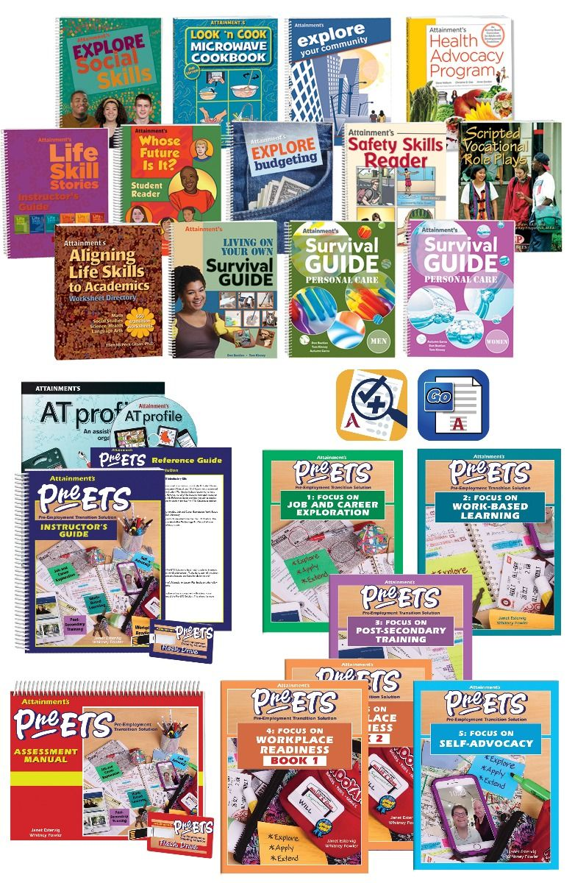
9. FORMS
Permission (Available in English and Spanish)
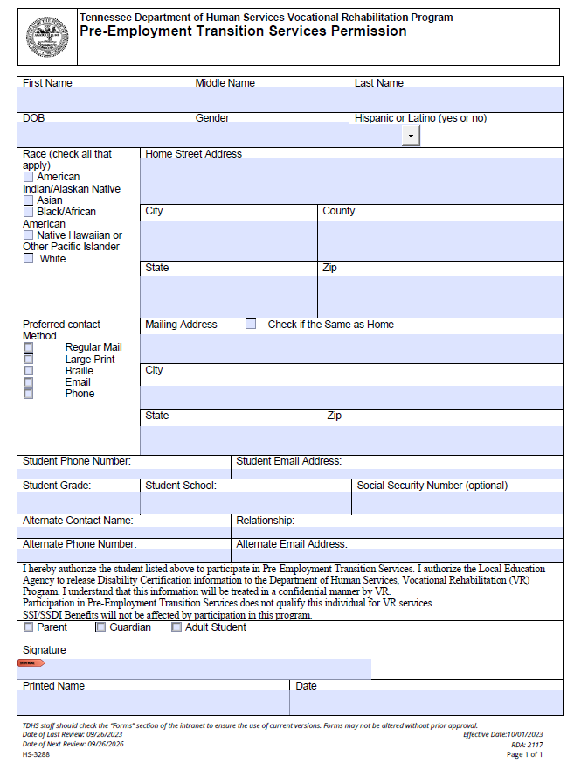

Attendance Log: NOTE: Please be sure the log is accurate, thorough and matches the report for the service(s) provided including the number of units. Units are counted in 15- minute increments and more than one (1) unit is required to bill. Please ensure the instructional code (JEC, WBL, PSC, WRT, SAS) is correct and corresponds to the information entered in Core’s electronic case management system (Practical Health).

Student Report
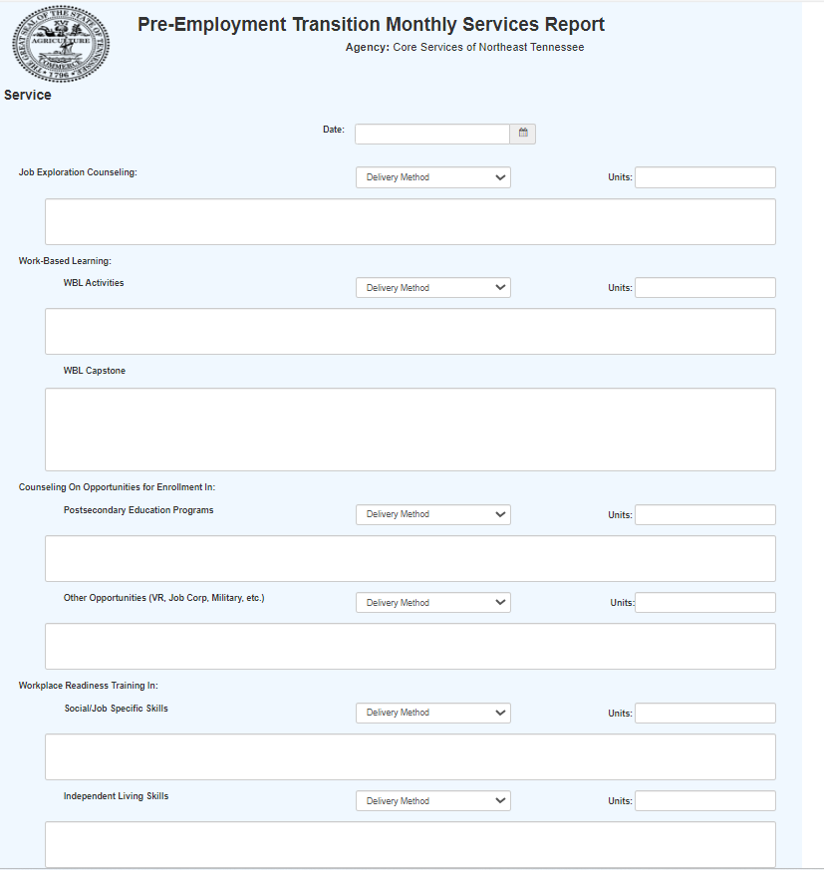

10. NAVIGATING ELECTRONIC CASE MANAGEMENT SYSTEM - PRACTICAL HEALTH:

- Set Up and Clock In

- Case Management System
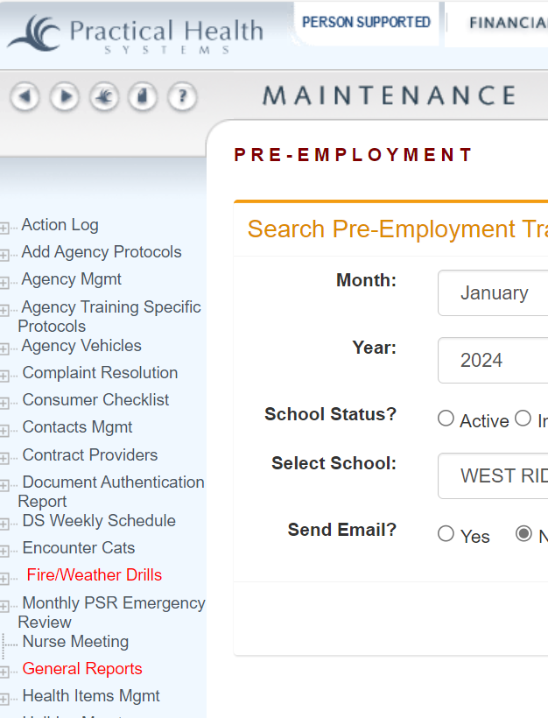
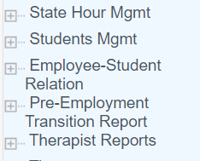
2
3

Choose the correct school
1

4

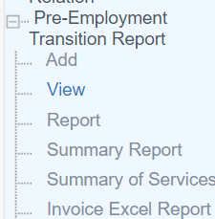
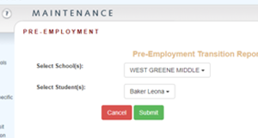
Click on submit to bring up the student report
Choose all students who attended the class

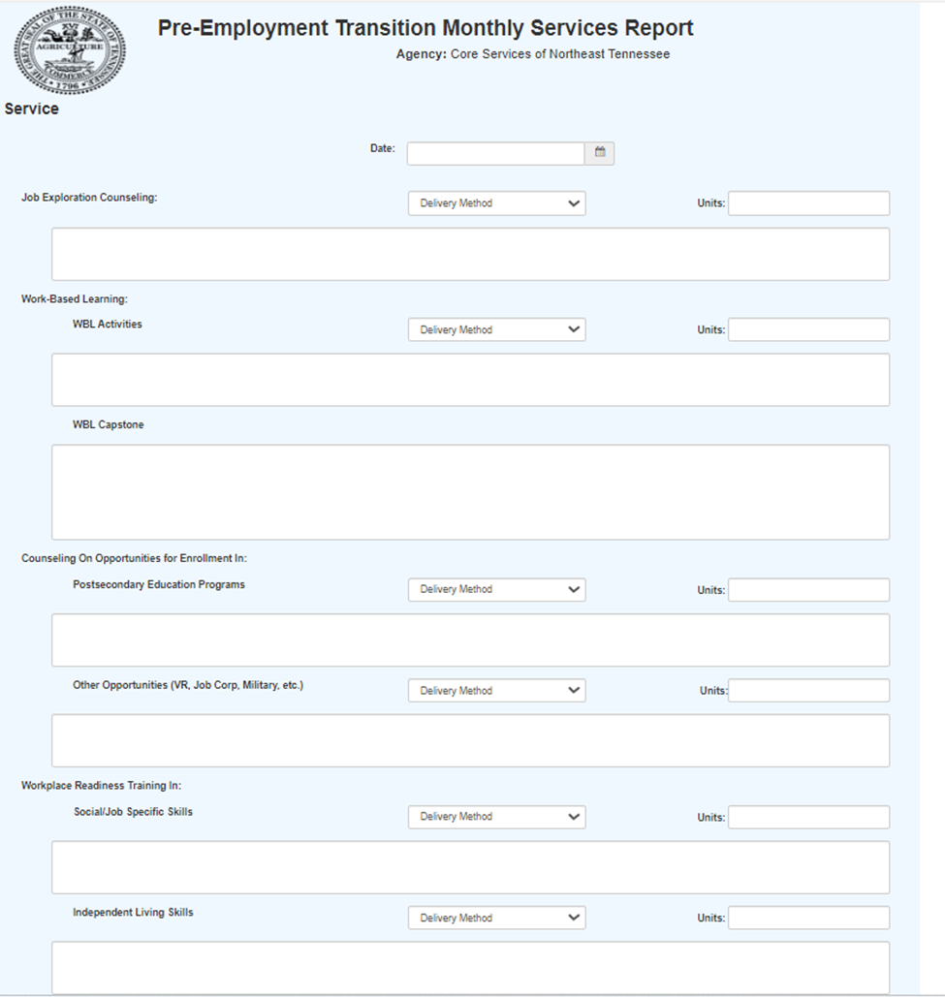
- Completing a Student Report
- Select Date of Class
- Pick the Pre-ETS topic area
- Enter the number of units in 15 minute increments
- Select the method of delivery (in-person, remote)
2
1
3
4
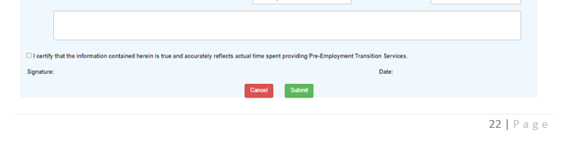
11. RESOURCES
Be sure to certify and submit or your work will be lost.
Units are recorded in 15-minute increments:
1 = 15 minutes
2 = 30 minutes
3 = 45 minutes
4 = 60 minutes
 | https://transitiontn.org/
 | https://www.tn.gov/humanservices/ds/vocational-rehabilitation/transition-services/pre-employment-transition-services.html
 | http://www.wintac.org/topic-areas/pre-employment-transition-services
 | https://www.coreservicestn.com/
 | https://www.tn.gov/content/dam/tn/human-services/documents/TN%20Virtual%20Pre-ETS%20Best%20Practice%20Guide_FINAL.pdf
REQUIRED ACTIVITIES WORKSHEET – Provided by | Attachment A

ATTACHMENT A
Required Activities for Pre-etS
Job Exploration Counseling
Job Exploration Counseling, or Career counseling can include a wide variety of professional activities which help individuals with career-related issues. Career counselors work with youth seeking to explore career options, experienced professionals contemplating a career change, parents who want to return to the world of work after taking time to raise their child, or people seeking employment. Career counseling is also offered in various settings, including in groups and individually, in person or virtually.
Discussion or counseling of job exploring options are intended to foster motivation, consideration of opportunities and informed decision-making. Specific to youth, real-world activities ensure that students recognize the relevance of a high school and post-school education to their futures, both in college and/or the workplace. Job exploration counseling activities can be done in conjunction with private, for-profit, public or nonprofit businesses in your community and/or through web-based resources.
Job Exploration Counseling may include discussion or information on:
•The student's vocational interest inventory results
•The labor markets
•In-demand industries and occupations,
•Non-traditional employment options,
•Administration of vocational interest inventories, and
•Identification of career pathways of interest to the students.
Students may be participating in a number of pre-employment transition services or transition services through VR or Education. Discussion or counseling on the results of some of these activities can help to identify viable career options or solidify careers that a student will want to explore further.
Work-based learning experiences, which may include in-school or after school opportunities, experiences outside of the traditional school setting, and/or internships
Work-Based Learning Experiences (WBL)
(WBL may include in-school or after school opportunities, or experience outside the traditional school setting (including internships), that is provided in an integrated environment to the maximum extent possible)
Work Based Learning is an educational approach or instructional methodology that uses the workplace or real work to provide students with the knowledge and skills that will help them connect school experiences to real-life work activities and future career opportunities. It is essential that direct employer or community involvement be a component of the WBL to ensure in-depth student engagement. These opportunities are meant to engage, motivate and augment the learning process. These WBL opportunities can be done in conjunction with private, for-profit, public or nonprofit businesses in your community and/or through web-based resources. In addition, work-based learning requires in-depth engagement of youth and an evaluation of acquired work relevant skills.
Work-based learning experiences, may include:
• Job Shadowing
• Career Mentorship
• Career Related Competitions
• Informational Interviews
• Paid Internships
• Non-paid Internships
• Practicum
• Service Learning
• Student-led Enterprises
• Simulated Workplace Experience
• Paid Work Experience
• Non-Paid Work Experience
• Volunteering
• Workplace Tours/Field Trips
These WBL opportunities can be done in conjunction with private, for-profit, public or nonprofit businesses in your community and/or through web-based resources. In addition, work-based learning requires in-depth engagement of youth with oversight and evaluation of acquired work relevant skills by identified staff. The work-based learning experience must be provided in an integrated setting in the community. Where paid WBL experiences are provided, the wages are to be paid at no less than minimum wage.
Choosing a career requires student exploration and planning. It is important that students connect the present to the future. It is essential for them to see how skill development and knowledge relate to future opportunities in postsecondary Education (PSE) settings and employment.
Individualized student strategies to support a smooth transition from high school to postsecondary education (PSE) include:
• document academic accommodations
• advocate for needed accommodations & services
• identify interests, abilities,
• talents, needs, learning style preferences and goals
• promote use of executive function skills
• assist with researching career & PSE options
• promote participation in PSE preparation classes, etc.
• connect to PSE resources/ services/websites
• promote use of self-advocacy skills
• assist with application/ enrollment process
• identify financial aid options
• take career vocational assessments
• familiarize with education and vocational laws
• identify technology needs
• identify admission tests accommodations
• attend college fairs & tours
• apply for Vocational Rehabilitation services, if eligible
• provide PSE information to family members
• access services & supports from developmental/ intellectual disabilities service agency, if eligible
Counseling on Post -Secondary Education
(Counseling opportunities for enrollment in comprehensive transition or post- secondary educational programs at institutions of higher education)
It is essential that students and their family members are provided information and guidance on a variety of postsecondary education and training opportunities. This includes information on:
•Community Colleges (AA/AS degrees, certificate programs and classes)
•Universities (Public & Private)
•Career pathways related workshops/training programs
•Trade/Technical Schools
•Military
•Postsecondary programs at community colleges and Universities for students with intellectual and developmental disabilities.
Workplace Readiness Training
(Workplace Readiness Training to develop social skills and independent living)
Workplace readiness traits describe a number of commonly expected, skills that employers seek from most employees. Work readiness skills are a set of skills and behaviors that are necessary for any job. Work readiness skills are sometimes called soft skills, employability skills, or job readiness skills.
These abilities help employees learn how to interact with supervisors and co-workers. They help reinforce the importance of timeliness and build an understanding of how we are perceived by others. Employers value employees who can communicate effectively and act professionally. No matter what technical skills a job may require, every job requires good social skills/interpersonal skills.
Specific social/interpersonal skills include:
• communication
• positive attitude
• teamwork
• problem solving
• talking/writing
• cooperation
• active listening
• decision making
• conflict resolution
• body language
• empathy
• professionalism
• good manners
• supporting others
• respectful
Independent livings skills include the following:
• good hygiene
• time management
• healthy lifestyle
• using a cell phone
• using transportation
• money management
• nutrition/meal preparation
• accessing community
• services & supports
• community participation
• civic responsibility
• community safety
• developing friendships
• appropriate dress
• appropriate behavior
Instruction in self-advocacy
(Instruction in self-advocacy which may include peer mentoring)
Self-advocacy refers to: an individual's ability to effectively communicate, convey, negotiate or assert his/her own interests and/or desires. Self-determination means that individuals with disabilities have the freedom to plan their own lives, pursue the things that are important to them and to experience the same life opportunities as other people in their communities. It means taking the responsibility for communicating one’s needs and desires in a straightforward manner to others. The development of self-advocacy skills should be started at an early age. These skills will be needed in education, workplace and community settings.
Self-advocacy skills include:
• self -awareness
• disability understanding
• disability disclosure
• decision making
• set goals
• evaluate options
• identify independence
• accommodations
• request & utilize accommodations
• know your rights & responsibilities
• self-determination
• know how to request & accept help
• intrinsic motivation
• taking a leadership role
• in support plans
• assertiveness
• listen to others opinions
• problem solving
• monitor progress
• positive self-talk
Self-determination is a concept reflecting the belief that all individuals have the right to direct their own lives. Students who have self-determination skills have a stronger chance of being successful in making the transition to adulthood, including employment and independence. To accomplish this goal, students must be prepared to participate in planning for their future.

